The electrical system of the heart
The four chambers of the heart, the atria and ventricles work in coordinated fashion. The atria receive blood from the lungs and the rest of the body and the ventricles pump blood back out to the lungs and the body. The conducting tissue of the heart coordinates muscle contraction using electrical impulses. These are generated in the sinoatrial (SA) node in the right atrium. They then spread to the left atrium and the atriovenricular (AV) node, which is located in the junction between the atria and ventricles. The AV node then transmits the impulses to the so-called His-Purkinje network, a complex system of conducting fibres. The signals finally reach the heart muscle and trigger a contraction.
In some patients with heart failure, there is a delay in conduction of electrical impulses in parts of the heart. This delay, or ‘dysynchrony’, interferes with contraction of the heart muscle. As a result, less blood is pumped out of the heart in every beat.

Electrical system of the heart
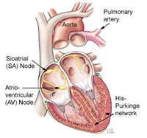

How does CRT work ?
Cardiac resynchronisation therapy (CRT) is aimed to correct delays in electrical impulses across the heart. It does so by delivering electrical impulses to various areas of the heart, usually three – the right atrium, the right ventricle and the left ventricle. The CRT device consists of an impulse generator, a battery and has 2 or 3 leads (wires) that are anchored in the heart muscle. The leads are introduced through veins below the collar bone and passed into the right atrium and right ventricle, as is the norm with ordinary pacemakers. In the case of CRT, another lead is passed into the system of veins that surround the left ventricle (coronary sinus). The leads are then connected to the CRT device, which is placed under the skin or muscle below the left or the right collar bone. Sometimes CRT devices are implanted via the femoral vein in the right groin.

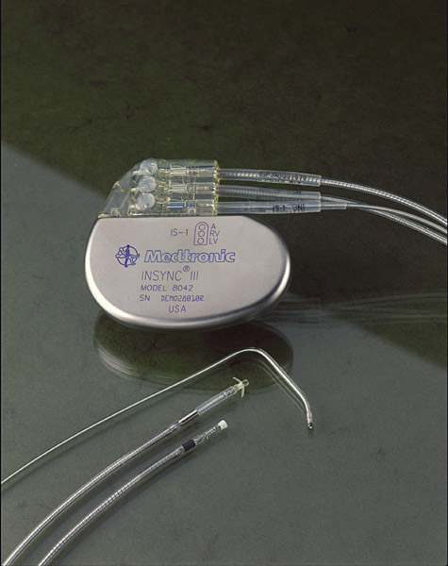

CRT with defibrillator therapy
CRT can be combined with a cardiac defibrillator (ICD). This device detects abnormal heart rhythms (ventricular tachycardia and fibrillation) and shocks the patient out of the rhythm with an electrical discharge. Currently, around 80% of patients who are treated with CRT receive this combination (CRT-D).

What are the benefits of CRT ?
Numerous studies have shown that CRT prolongs survival and improves symptoms, such as breathlessness and fatigue. In addition, CRT helps prevent hospital admissions with acute heart failure and fluid in the lungs (‘pulmonary oedema). Recently, some studies have shown that CRT is also beneficial in patients who are only marginally breathless.

Who should have CRT ?

Not all patients with heart failure benefit from CRT. Generally, it is beneficial for patients who:

- Have systolic heart failure
- Are breathless / fatigued despite taking medication (including ACE inhibitors, beta-blockers)
- Have a QRS duration greater than 120 milliseconds on the ECG
- Have a left ventricular ejection fraction <35%

There is also evidence to show that changing, or ‘upgrading’ from a conventional pacemaker to a CRT device is beneficial in patients whose breathlessness is linked to poor function of the left ventricle (heart failure).

What does the procedure involve ?

The procedure is carried out the the ‘cath lab’. You will be lying down and given local anaesthetic and a sedative to make you sleepy.

- Electrodes (sticky patches) will be placed on the chest and back, to allow monitoring of the heart rhythm during the operation.
- A cuff will be placed on your arm and connected to a blood pressure monitor
- A small monitor will be placed on your finger for monitoring the oxygen level in your blood.
- The X-ray machine will move around you during the operation.
- After injection of local anaesthetic, a small incision will be made on the chest, usually below the left or right collar bone.
- The leads will then be passed into the heart trough veins. Two leads are introduced into to the right atrium and right ventricle,. The third lead is introduced into the veins that surround the left ventricle. The lead tips are anchored to the heart muscle at one end and to the device at the other end. The device is then placed in a packet under the tissues of the chest.
- Sometimes, it is impossible to place the leads on the left side of the heart, but this is uncommon, in less than 3% of cases. A repeat procedure may be required if the leads displace.
- The procedure usually takes about an hour, but can take longer.

After the procedure

- Most patients can go home the following day.
- The device and the leads will be retested before you go home.
- You may feel discomfort at the site of the operation, but this settles within two days.
- You must contact us directly if you see redness or discharge from the site or if you feel unwell.
- Arrangements will be made for you to have the stitches removed.

Follow-up
- After device implantation, planned follow-up appointments will be undertaken at:
- 1 week following implantation for stitch removal and inspection of wound site
- 1 month
- 3 months
- Every 6 months thereafter
The following procedures will be undertaken at each follow-up visit:
- Device check, to ensure that the device and the leads are working properly. This involves getting information from the device remotely using radiowave transmition.
- Echocardiogram, to see whether the heart function is changing. By looking at the echocardiogram, we can reprogram your device top achieve the best response from the heart.
- Other investigations may include an ECG, blood tests and chest X-rays.

CRT and ICD links: http://my.clevelandclinic.org/heart/services/tests/procedures/biventricular_pm.aspx

Telemonitoring

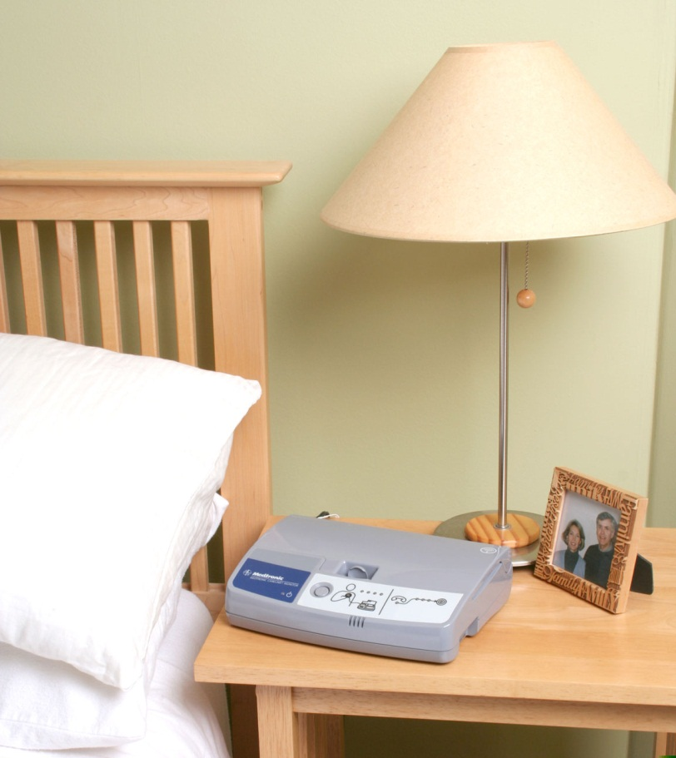

Before the procedure

Where is the procedure performed?
In most cases, the implant procedure takes place in a special room in the Electrophysiology Lab. When the epicardial implant approach is used (see next page), the procedure takes place in a surgical suite.

Should I take my medications?
If you take Coumadin, the results of your INR test (a blood test to evaluate the blood clotting) must be within a suitable range before the implant procedure can be performed. Usually you will be instructed to stop taking anticoagulant medications, including aspirin or Coumadin (warfarin), a few days before the procedure.
Your doctor may also ask you to stop taking other medications, such as those that control your heart rate. Do not discontinue any of your medications without first talking to your health care provider. Ask your doctor which medications you should stop taking and when to stop taking them.
If you have diabetes, ask the nurse how to adjust your diabetes medications or insulin.

Can I eat?
Eat a normal meal the evening before your procedure. However, DO NOT eat, drink or chew anything after 12 midnight before your procedure. This includes gum, mints, water, etc. If you must take medications, only take them with small sips of water. When brushing your teeth, do not swallow any water.

